True Crime Club
March 5th at 6pm
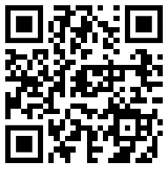
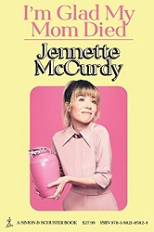
I’m Glad My Mom Died by Jennette McCurdy is available for free with use of your library card at tinyurl.com/CRDLmccurdy

This will be our primary source of information on our discussion of child stardom, however if you'd prefer to research further (or differently) Check out the list of below for some suggested researching.

Articles and Online Resources:  - 11 Child Stars Who Opened Up About The Mistreatment And Exploitation They Faced As A Result Of Childhood Fame  tinyurl.com/BUZZchildstars  - Mara Willson’s writes a New York Times article about her experiences as a child star: The Lies Hollywood Tells About Little Girls  tinyurl.com/NYTmara  - Biography Article on Judy Garland’s treatment while filming Wizard of OZ at 17  https://tinyurl.com/BIO-garland  - An article on child labor laws and internet fame: 'It's not play if you're making money': how Instagram and YouTube disrupted child labor laws  https://tinyurl.com/GUARDIANchildlabor | 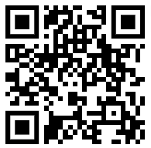  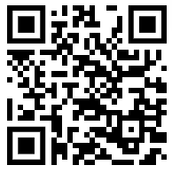  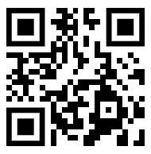  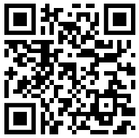 | Videos:  - Jennette McCurdy & Drew Barrymore interview on Complicated Relationships with Mothers  tinyurl.com/BARRYMOREmccurdy  - A short video clip on the death of child star Bobby Driscoll (voice of Disney’s peter pan)  tinyurl.com/ASKdriscol  - Framing Britney Spears Documentary  tinyurl.com/NYTspears  Books:  - Read Little Girl Lost by Drew Barrymore  tinyurl.com/MELlostgirl | 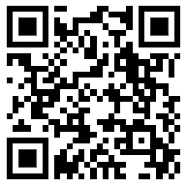  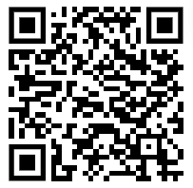  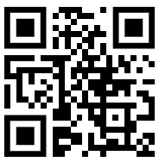  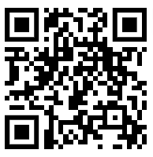

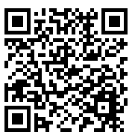
Follow the CRDL True Crime Club Facebook page to share even more interesting facts or sources you find! tinyurl.com/CRDLTrueCrimeClub

Upcoming Dates and Topics:
Meeting Date | Topic | Main Book: | order the Book:
March 5th @ 6pm | Child Stardom | I’m Glad My Mom Died by Janette McCurdy | tinyurl.com/CRDLmccurdy
April 2nd @ 6pm | The Murders of Tammy Homolka, Leslie Mahaffy and Kristen French (Barbie and Ken Murders) | TBA | 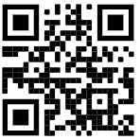https://mel.org/welcome
May 7th @ 6pm | TBA | TBA | https://mel.org/welcome

